Implement Cloud Monitoring Solutions

Problem Statement:

Once an application is deployed and scaled, visibility is critical. Without monitoring, issues go unnoticed until customers complain. In this lab, we’ll implement AWS CloudWatch monitoring for your ECS-based application, enabling centralized logs, custom metrics, alarms, and dashboards for proactive incident detection.

Tools/Software Versions:

1. AWS CLI: v2.28.21

2. ECS Cluster: sample-app-cluster

3. ECS Service: sample-app-service

4. Cloud Monitoring: Amazon CloudWatch

5. Logging: CloudWatch Logs

6. Alerting: CloudWatch Alarms + SNS

7. Dashboard: CloudWatch Dashboards

Hands-on Steps:

Step 1: Verify or Create a CloudWatch Log Group

We need a centralized log group to capture ECS container logs. Some environments may already have the log group created, so we check first.

1. Check if the log group exists:

aws logs describe-log-groups \
--log-group-name-prefix /ecs/sample-app \
--region ap-south-1

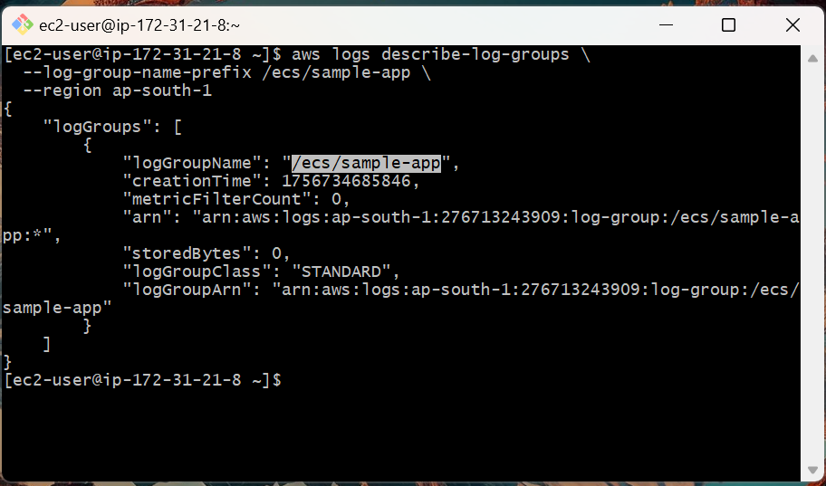

If you see /ecs/sample-app in the output, the log group already exists. No need to create it again.

If nothing is returned → create it with:

aws logs create-log-group \
--log-group-name /ecs/sample-app \
--region ap-south-1

2. Verify in the CloudWatch Console → Log groups that /ecs/sample-app is present.

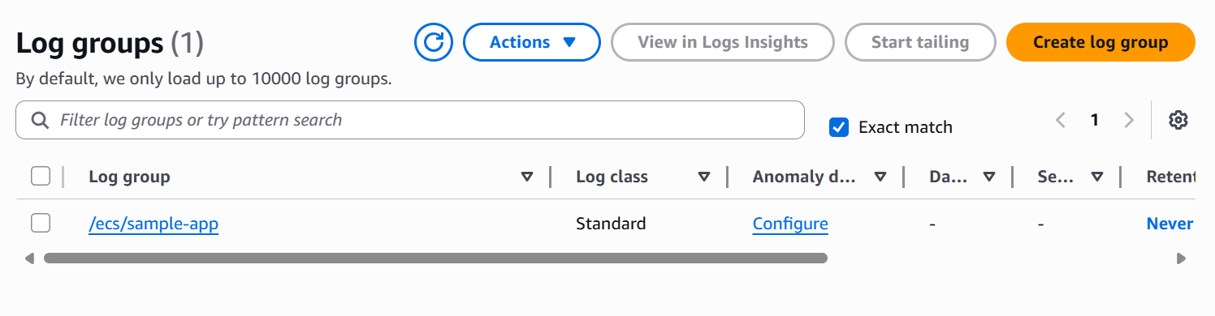

Step 2: Enable ECS Task Logging

We’ll configure the ECS task definition so that container logs flow into CloudWatch. This requires preparing a JSON file locally and then registering it with ECS.

1. Create the JSON file on your EC2 instance:

cd ~/workspace
nano task-def-with-logs.json

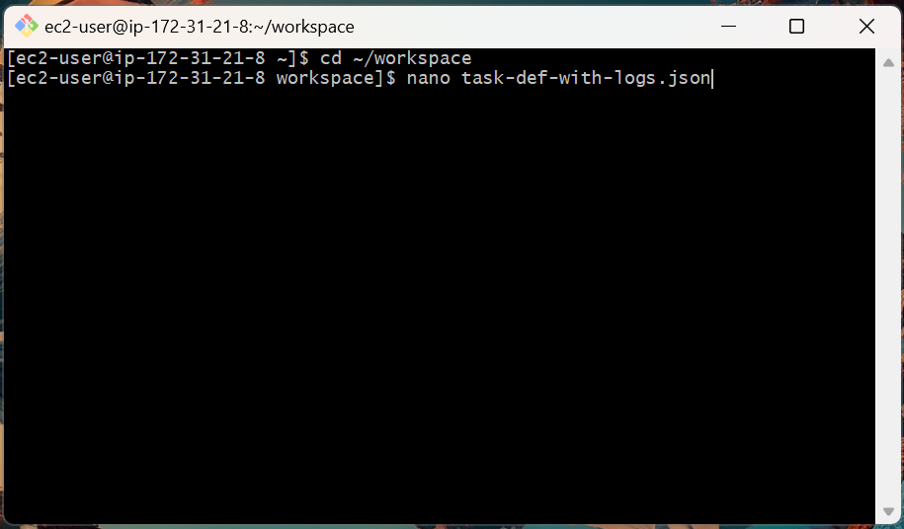

2. Paste the following content into the file:

{
"family": "sample-app",
"networkMode": "awsvpc",
"containerDefinitions": [
{
"name": "sample-app",
"image": "276713243909.dkr.ecr.ap-south-1.amazonaws.com/sample-app:latest",
"cpu": 512,
"memory": 1024,
"essential": true,
"portMappings": [
{
"containerPort": 3000,
"protocol": "tcp"
}
],
"logConfiguration": {
"logDriver": "awslogs",
"options": {
"awslogs-group": "/ecs/sample-app",
"awslogs-region": "ap-south-1",
"awslogs-stream-prefix": "ecs"
}
}
}
],
"requiresCompatibilities": ["FARGATE"],
"cpu": "512",
"memory": "1024",
"executionRoleArn": "arn:aws:iam::276713243909:role/ecsTaskExecutionRole"
}

3. Save and exit the file (Ctrl + O, then Enter, then Ctrl + X).

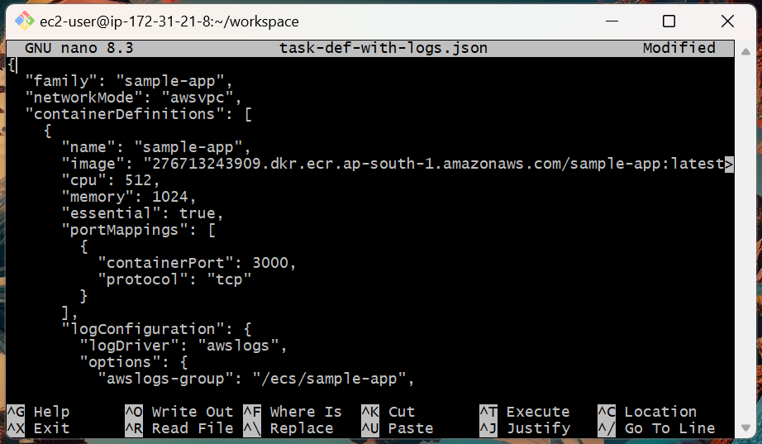

4. Register the new task definition with logging enabled:

aws ecs register-task-definition \
--cli-input-json file://task-def-with-logs.json

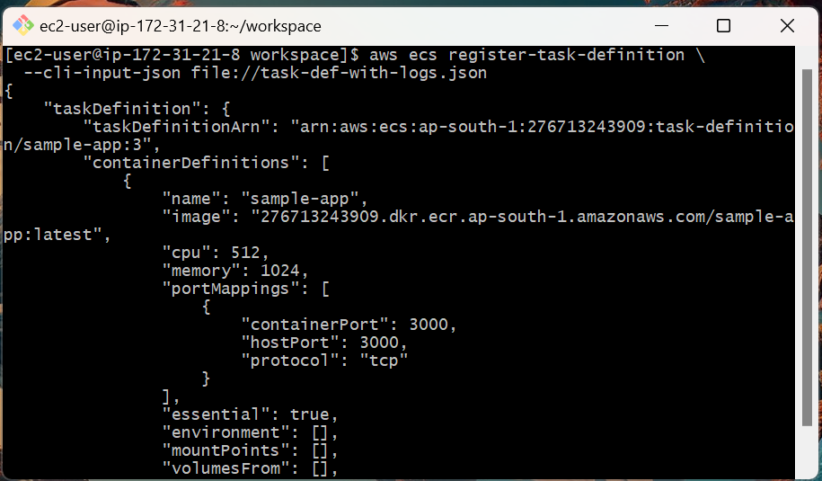

5. Update your ECS service to use the new task definition revision:

aws ecs update-service \
--cluster sample-app-cluster \
--service sample-app-service \
--task-definition sample-app:2 \
--region ap-south-1

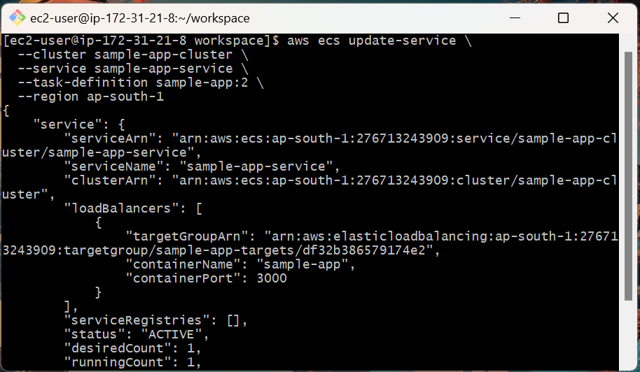

Step 3: View Logs in CloudWatch

With the new task running, your container output should appear in log streams.

1. Open CloudWatch Console → Logs → Log groups → /ecs/sample-app.

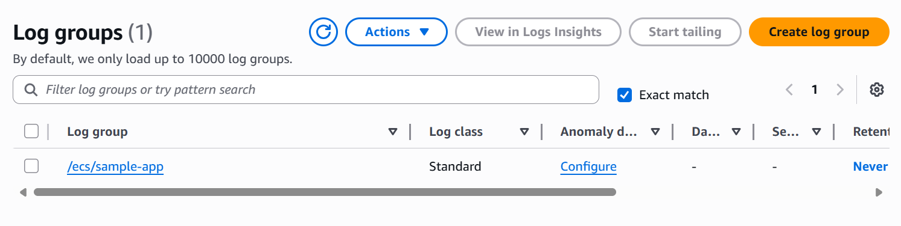

2. Open the Log streams section. You’ll see entries like ecs/sample-app/….

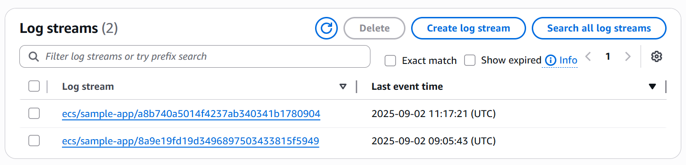

3. Click a stream to view logs (start/stop messages, requests handled, health checks).

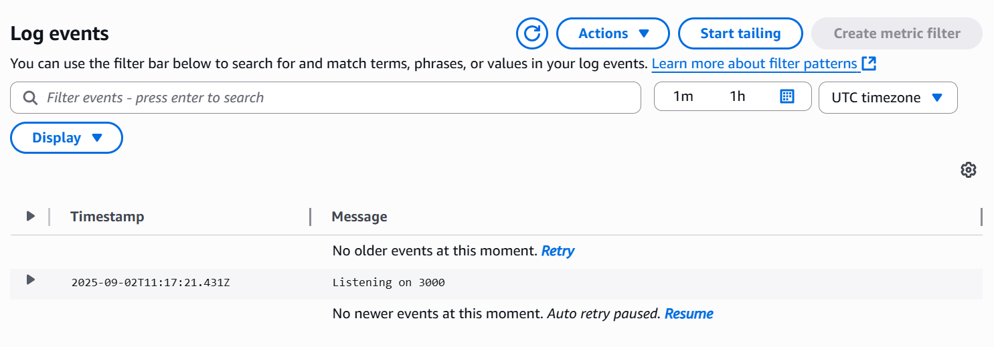

Step 4: Create CloudWatch Alarms (CPU Utilization)

We’ll get notified when the CPU crosses a threshold, so you know when the service is stressed.

1. Create a high-CPU alarm on the ECS service:

aws cloudwatch put-metric-alarm \
--alarm-name "HighCPU-SampleApp" \
--metric-name CPUUtilization \
--namespace AWS/ECS \
--statistic Average \
--period 60 \
--evaluation-periods 2 \
--threshold 70 \
--comparison-operator GreaterThanThreshold \
--dimensions Name=ClusterName,Value=sample-app-cluster Name=ServiceName,Value=sample-app-service \
--region ap-south-1

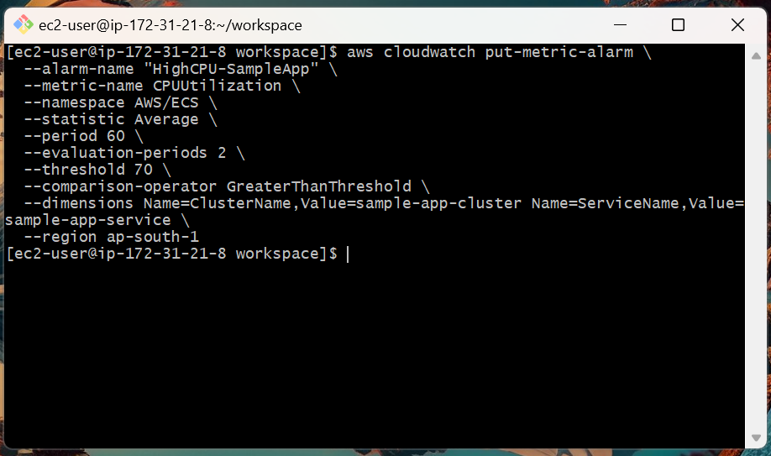

This alarm flips to ALARM if the average CPU > 70% for 2 minutes.

2. In CloudWatch → Alarms, HighCPU-SampleApp shows OK.

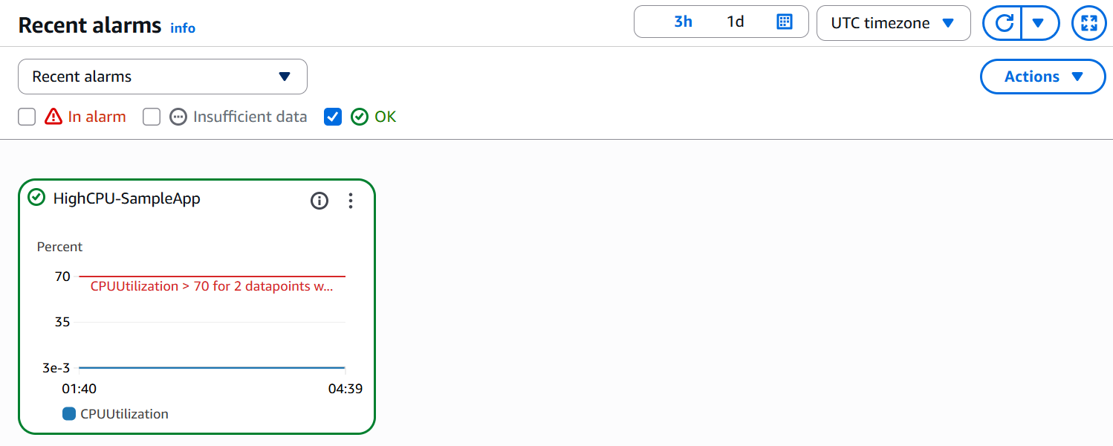

Step 5: Build a CloudWatch Dashboard (ECS metrics)

Put your key service metrics on one screen for quick checks.

1. Create the dashboard config:

cd ~/workspace
nano dashboard.json

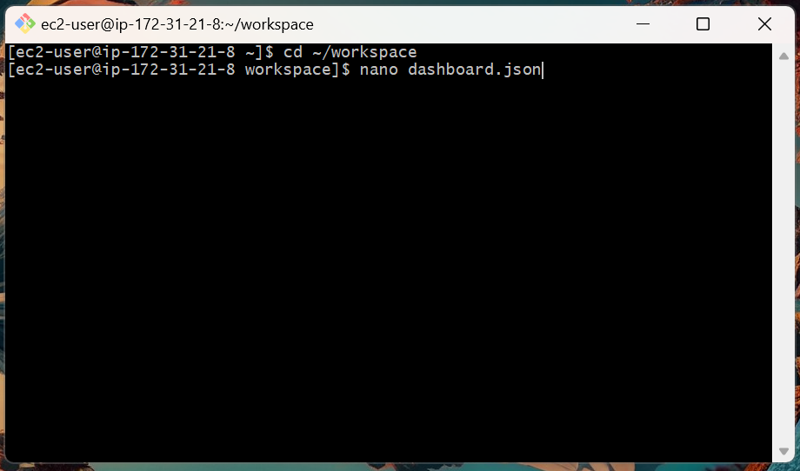

2. Paste this:

{
"widgets": [
{
"type": "metric",
"x": 0, "y": 0, "width": 12, "height": 6,
"properties": {
"metrics": [
[ "AWS/ECS", "CPUUtilization", "ClusterName", "sample-app-cluster", "ServiceName", "sample-app-service" ]
],
"stat": "Average",
"period": 60,
"region": "ap-south-1",
"title": "ECS Service CPU Utilization"
}
}
]
}

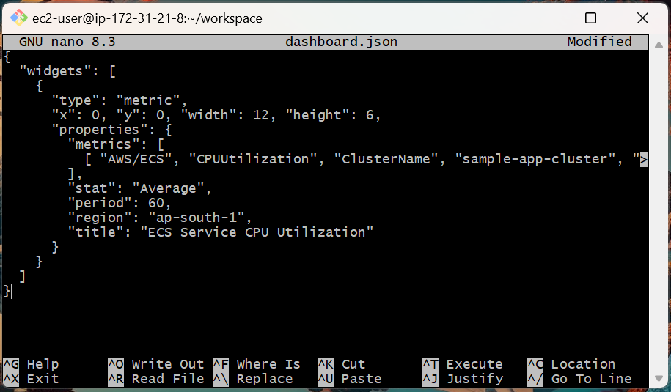

3. Save and exit the file (Ctrl + O, then Enter, then Ctrl + X).

4. Create the dashboard:

aws cloudwatch put-dashboard \
--dashboard-name SampleApp-Dashboard \
--dashboard-body file://dashboard.json \
--region ap-south-1

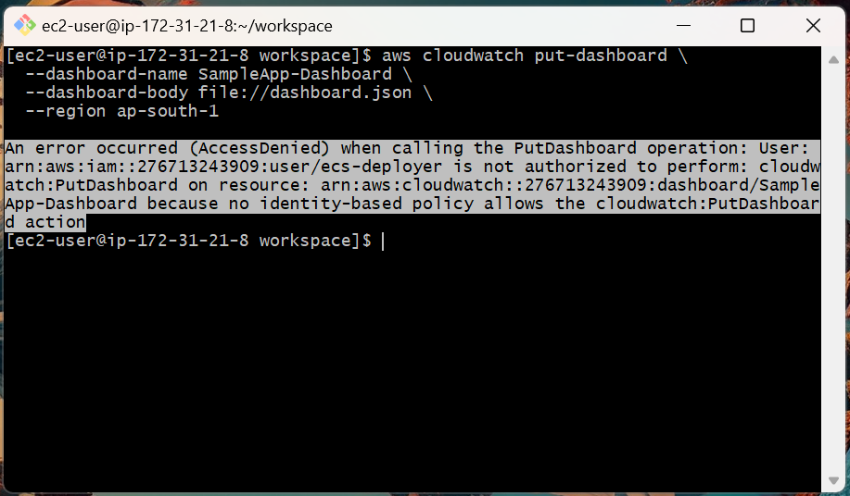

You might come across such an error as the ecs-deployer user doesn’t have permission to create dashboards.

To run this, attach a small permission so the current user can create the dashboard, then retry.

IAM → Users → ecs-deployer → Add permissions → Attach policies directly → CloudWatchFullAccess → Add.

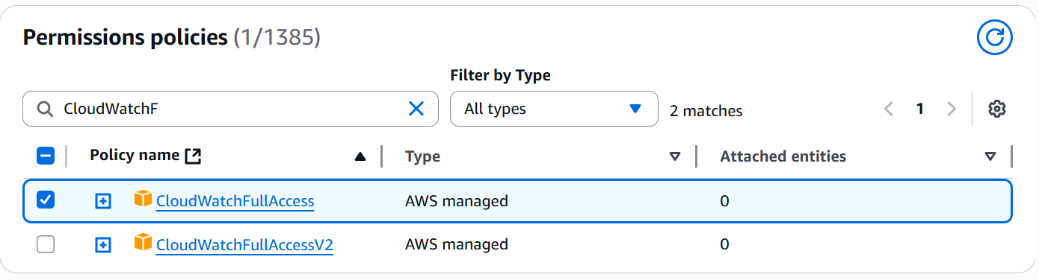

Then re-run the command with:

aws cloudwatch put-dashboard \
--dashboard-name SampleApp-Dashboard \
--dashboard-body file://dashboard.json \
--region ap-south-1

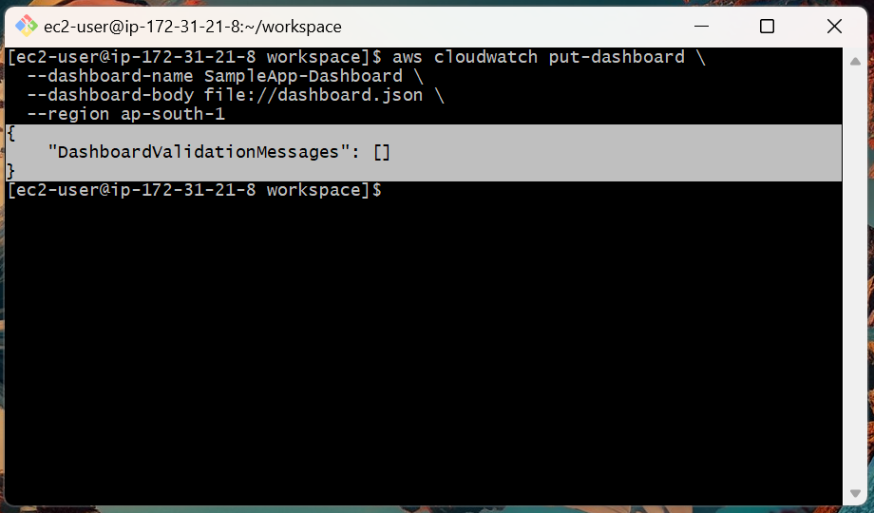

5. In CloudWatch → Dashboards, open SampleApp-Dashboard and see your CPU graph.

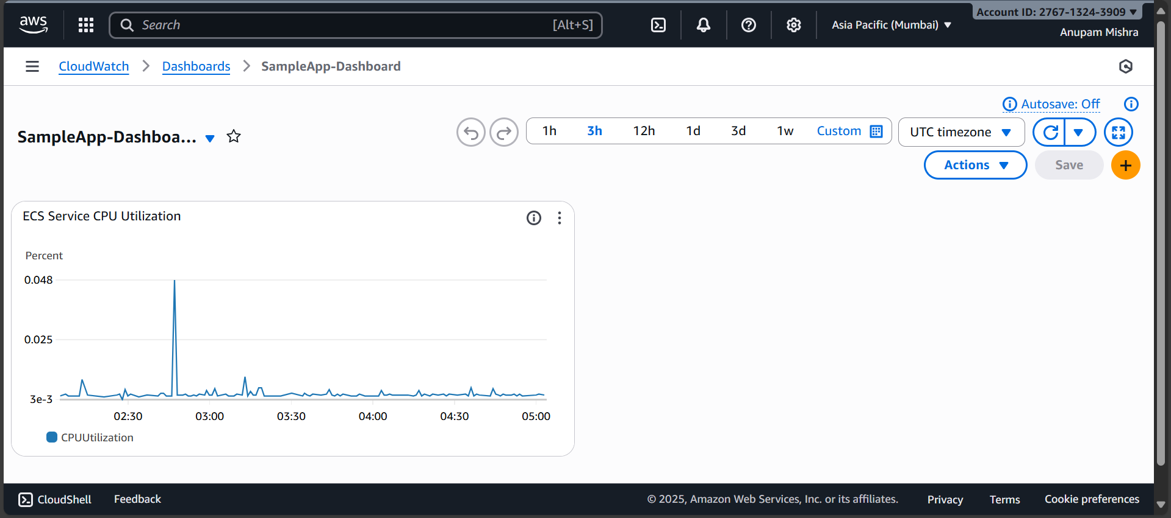

Topics Covered:

1. Streamed ECS container logs to CloudWatch Logs.

2. Located and viewed log streams for running tasks.

3. Created a practical, CPU-based CloudWatch alarm for the service.

4. Built a minimal CloudWatch dashboard for quick visibility.

